|  |  |  |  |  |  |
| --- | --- | --- | --- | --- | --- |
| Date | 5-Dec-22 | | | Tester Name | Mohammad Yusuf |
| Environment | Penfax - Test | | | Login used |  |
| Operating System | Select OS | Version: | Update: | | |
| Software Used | Select Software | Version: | Update: | | |
| Select Software | Version: | Update: | | |
| Release version |  | | | | |
| Title | M17 Contributions & DCT | | | | |
| Test Type | Regression | | | | |
| Test Scenario | M17.04 Abandon a file | | | | |
|  |  | | | | |
| Expected Results | Abandoned files can be seen when View Abandoned checkbox is checked. | | | | |
| Pass/Fail | Pass | | | JIRA# | N/A |

Describe your steps with screenshots:

1. Log into MEPP DCT and select the Employer from the dropdown.

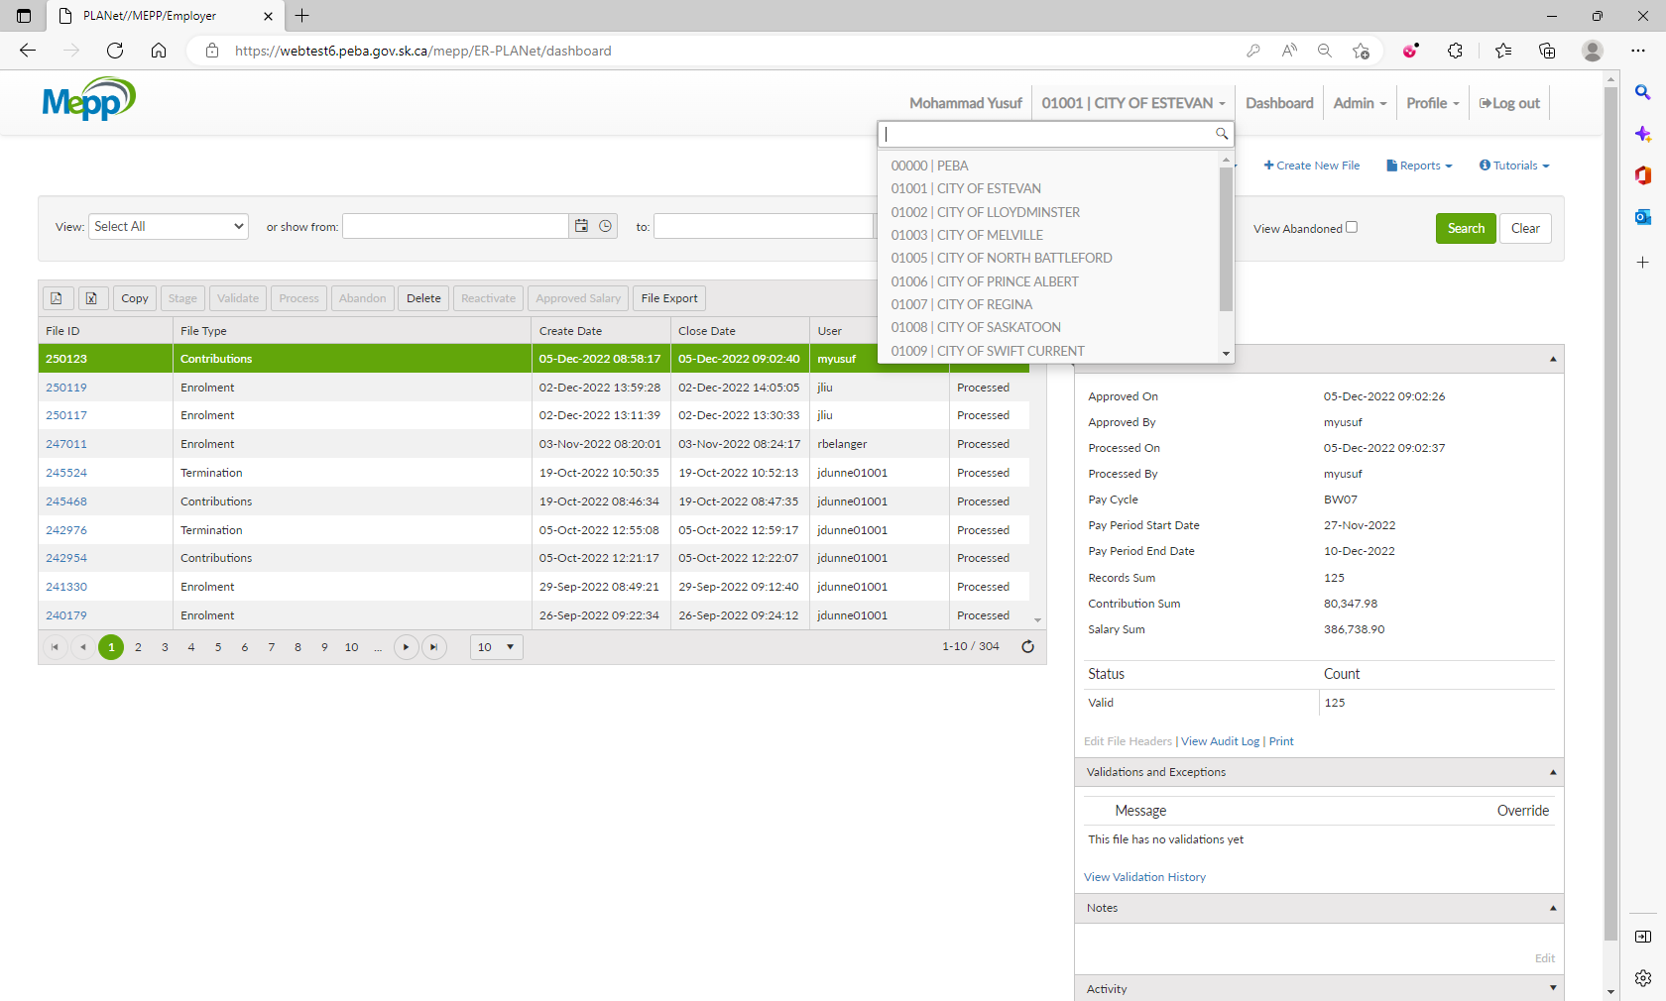

1. Click on Create New File.

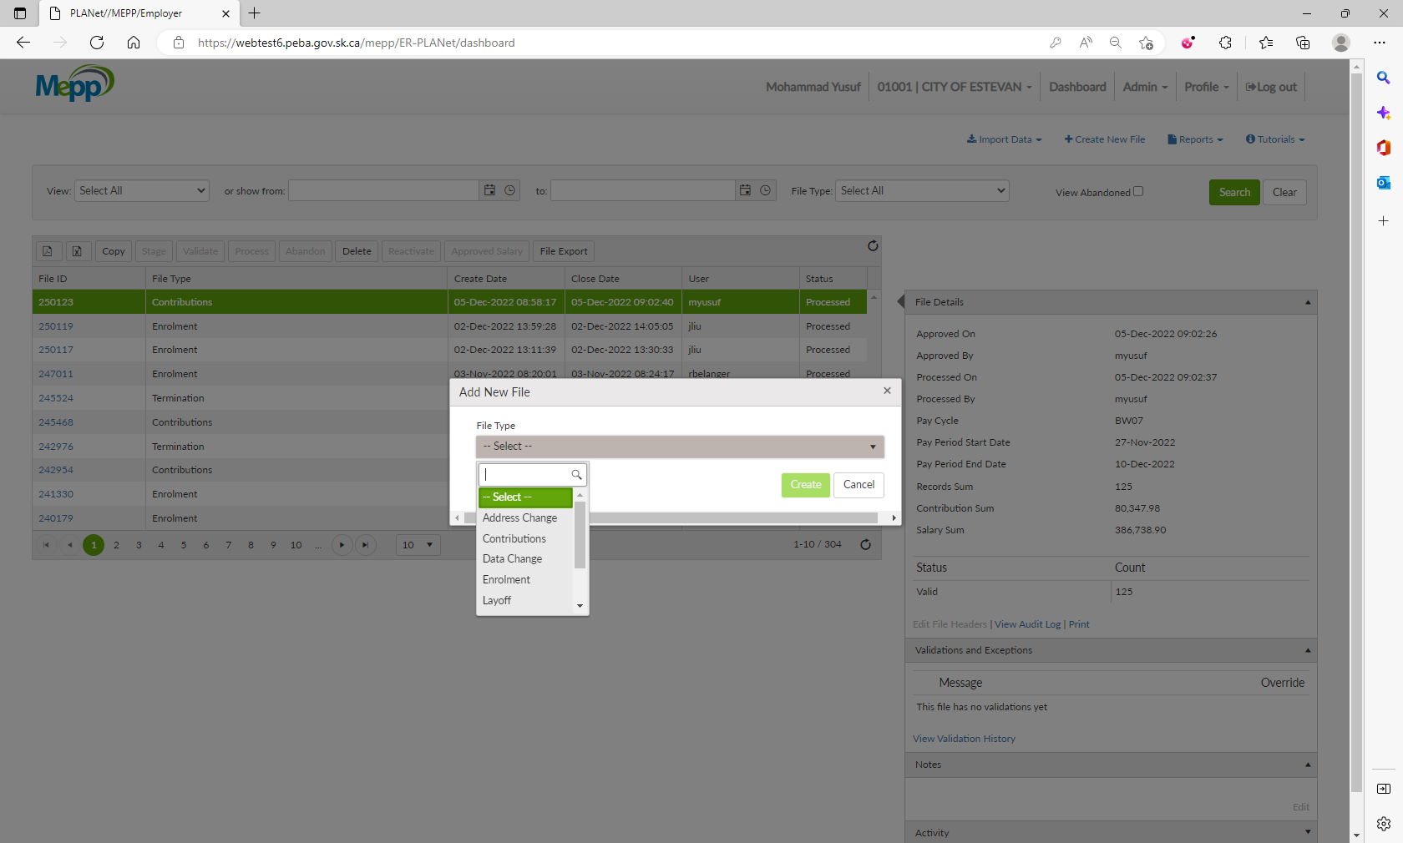

1. Select a file type from the dropdown and click on Create.

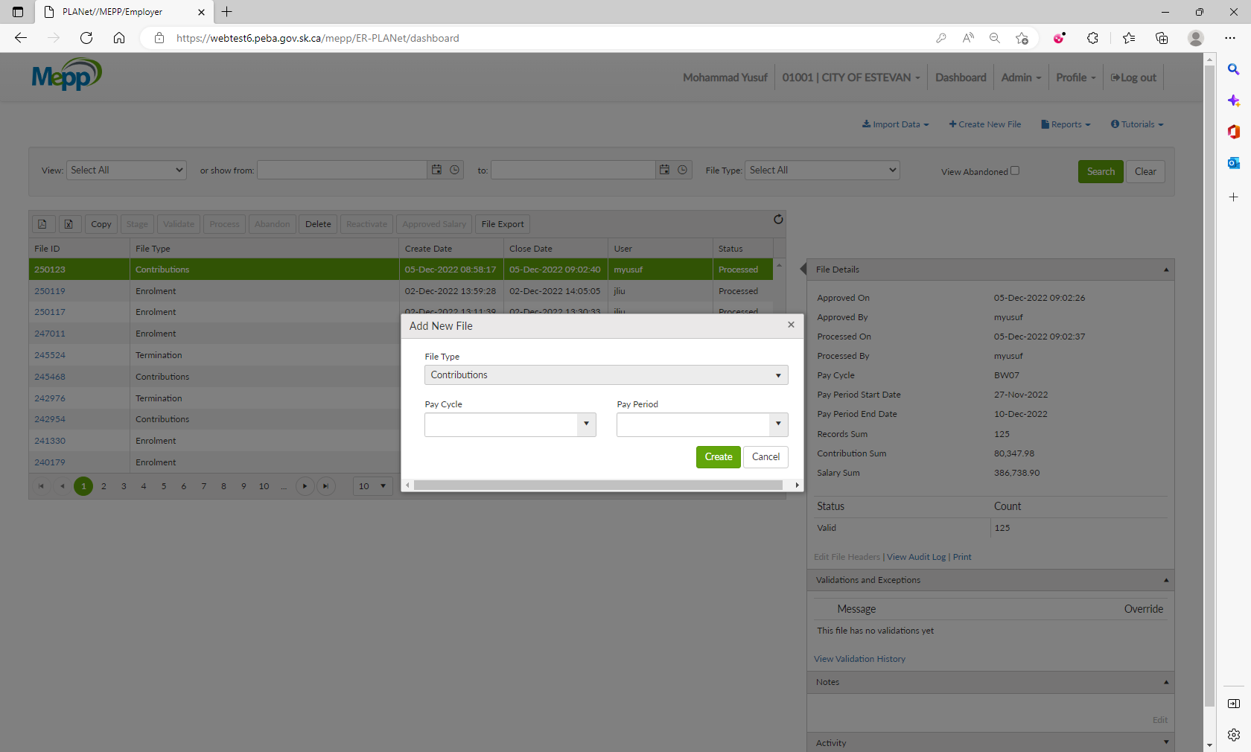

1. New file is created.

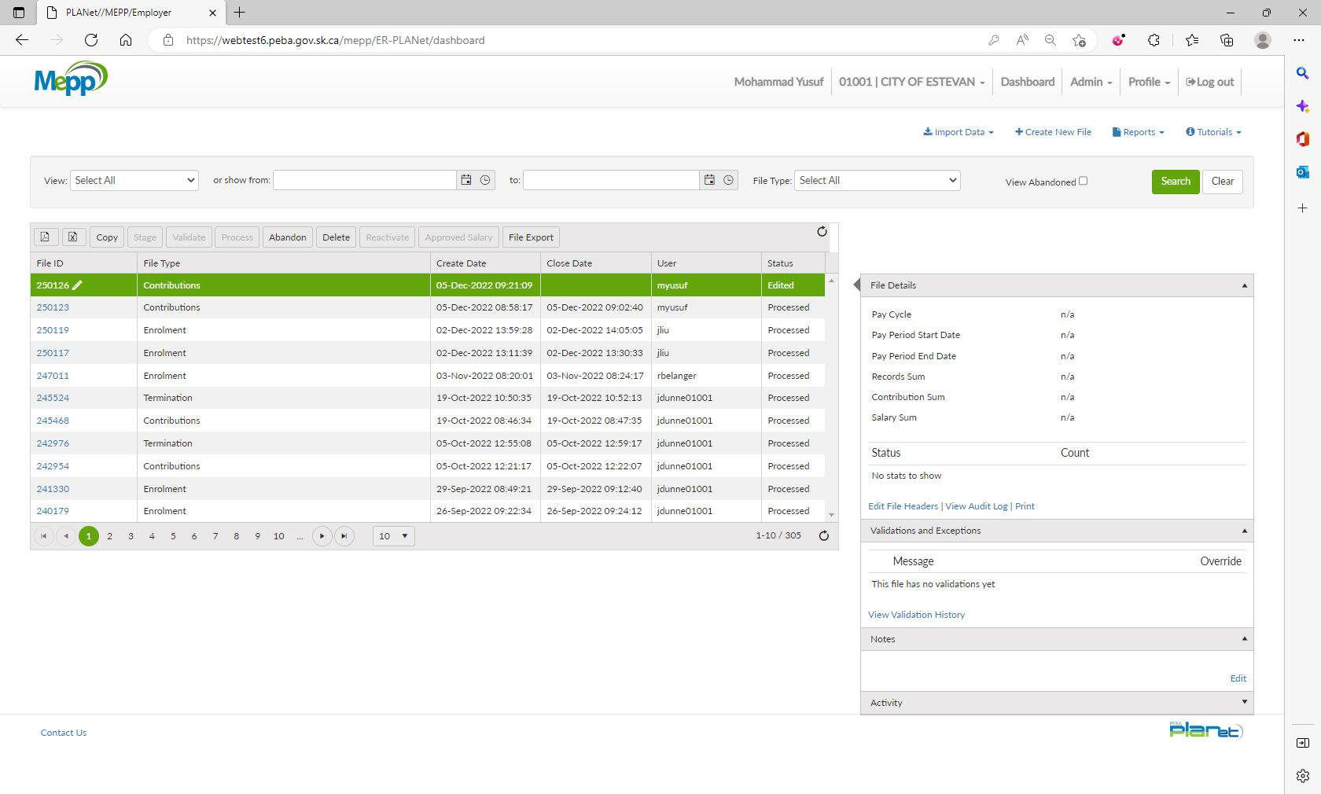

1. Click on Abandon.



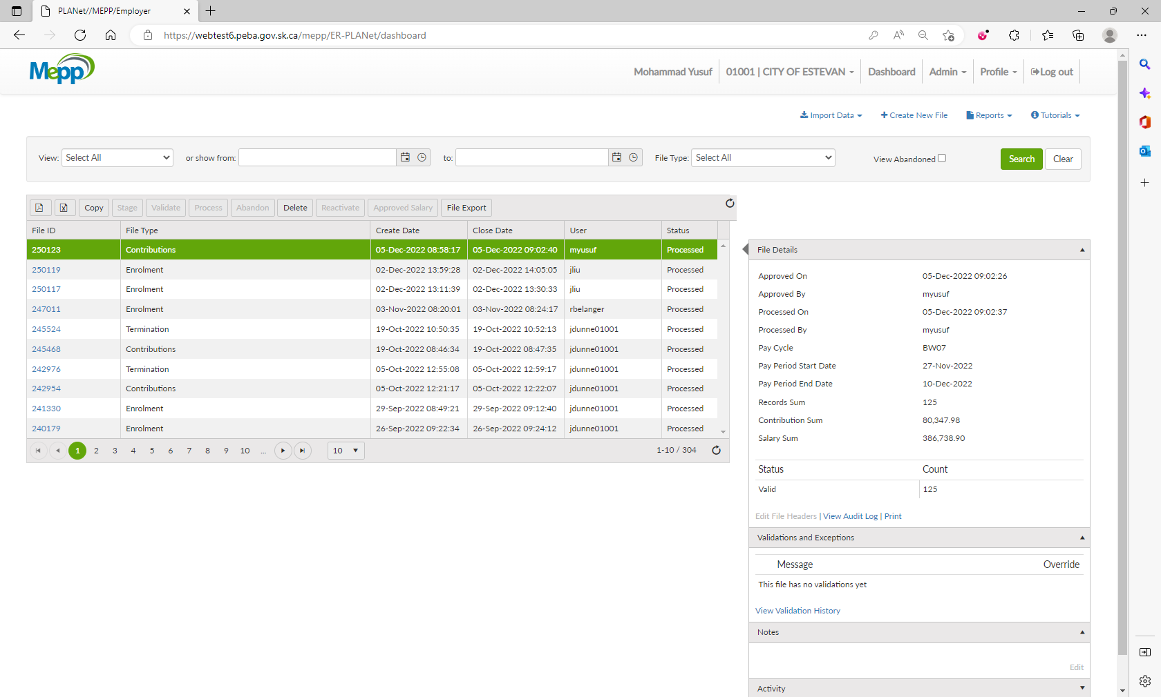

1. File is no more on the list.



1. If you want to see the abandoned files, tick the View Abandoned checkbox and click on Search.

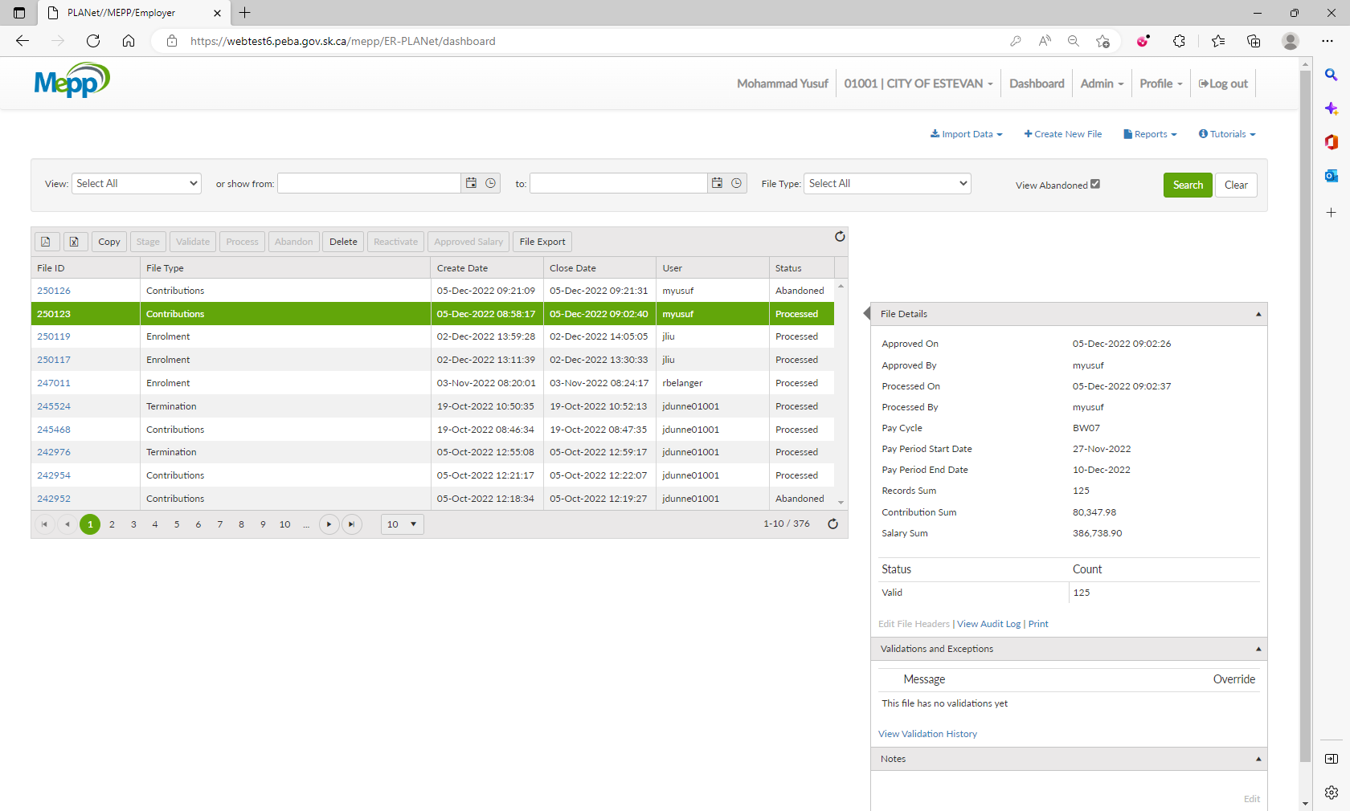

1. Now, you can see all the abandoned files on the list.

